Miss Naylor visiting graves of New Zealand soldiers in Nunhead Cemetery. The soldiers are from ...

Download Low Res Image
Order a copy
prev
next
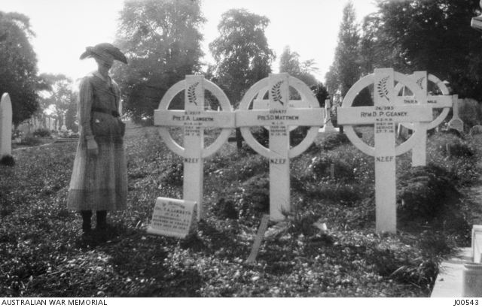
Unit | New Zealand Army
Places | - Europe: United Kingdom, England, Greater London, London  - Europe: United Kingdom, England, Greater London, London, Southwark, Nunhead Cemetery
Accession Number | J00543
Collection type | Photograph
Object type | Black & white - Film original negative nitrate other
Maker | Unknown
Place made | United Kingdom: England, Greater London, London
Conflict | First World War, 1914-1918
Copyright | Item copyright: Copyright expired - public domain  This item is in the Public Domain
Description
Miss Naylor visiting graves of New Zealand soldiers in Nunhead Cemetery. The soldiers are from the New Zealand Expeditionary Forces and are from left to right: Private T A Lawton: Private S D Matthew and Rifleman D P Geaney. Each cross has a metal silver leaf on the top. From the collection of Mr Alfred Thomas Sharp. Mr Sharp was the Commonwealth Immigration Officer of Victoria and was based in the London Office during the First World War. He and his wife hosted and visited many soldiers, particularly those from Victoria, who were recuperating in London. He also photographed many Australian graves in English cemeteries. His photograph collection relating to this period in London was bequeathed to the Memorial in 1922 after his death. During his time in London he was a member of the British Volunteer Regiment, serving with the Willesden Battalion, Middlesex Volunteer Regiment.

https://www.awm.gov.au/collection/C1900
04 July 2019

